QUESTION 6 – DEADLOCK HANDLING AND BANKER'S ALGORITHM

1. Introduction
Deadlock is a situation in which two or more processes wait indefinitely for resources held by one another.
Deadlocks are common in systems where multiple processes compete for limited resources.
In a research centre, multiple jobs may require GPUs, licenses and high-speed storage simultaneously.
If resources are allocated without proper planning, the system may enter a deadlock state.

2. Problem Description
Consider a research centre with five processes and three resource types.
The processes are P0, P1, P2, P3 and P4.
The resources represent different computing resources such as GPUs, software licenses and storage units.
The objective is to determine whether the system is in a safe state and whether a new resource request can be granted safely.

3. Necessary Conditions for Deadlock
Deadlock can occur when all four conditions are present simultaneously.
1. Mutual Exclusion: A resource can be used by only one process at a time.
2. Hold and Wait: A process holds one resource while waiting for additional resources.
3. No Preemption: Resources cannot be forcibly taken away from a process.
4. Circular Wait: A circular chain of processes exists where each process waits for a resource held by the next process.
These four conditions are known as the necessary conditions for deadlock.

4. Resource Allocation Graph
A Resource Allocation Graph represents processes and resources using nodes and directed edges.
- Process nodes represent running processes.
- Resource nodes represent available resource types.
- Request edges represent resources requested by processes.
- Assignment edges represent resources allocated to processes.
A cycle in the graph indicates a possible deadlock. In systems with multiple instances of a resource type, a cycle alone does not always prove deadlock.

5. Banker's Algorithm
Banker's Algorithm is a deadlock-avoidance algorithm.
It checks whether allocating resources to a process keeps the system in a safe state.
The algorithm uses the following data structures:
Allocation Matrix: Represents the resources currently allocated to each process.
Maximum Matrix: Represents the maximum resources required by each process.
Need Matrix: Represents the remaining resources required by each process.
Need = Maximum − Allocation
Available Vector: Represents the number of currently available resources.

6. Implementation and Execution
The program was implemented in C using the Banker's Algorithm.
The program calculates the Need Matrix and checks whether the system can complete all processes in a safe sequence.
Commands:
mkdir -p ~/OS_Assignment_2/Q6
cd ~/OS_Assignment_2/Q6

nano q6.c

gcc q6.c -o q6 -O2

./q6

7. Output Analysis
The program displayed the Allocation Matrix, Need Matrix and Available Resources.
Available Resources:
3 3 2
Need Matrix:
7 4 3
1 2 2
6 0 0
0 1 1
4 3 1
The system checked the available resources and calculated a safe execution sequence.
Observed Safe Sequence:
P1 → P3 → P4 → P0 → P2
The output confirmed:
System is in SAFE state.
This means that all five processes can complete execution in the calculated order without entering a deadlock state.
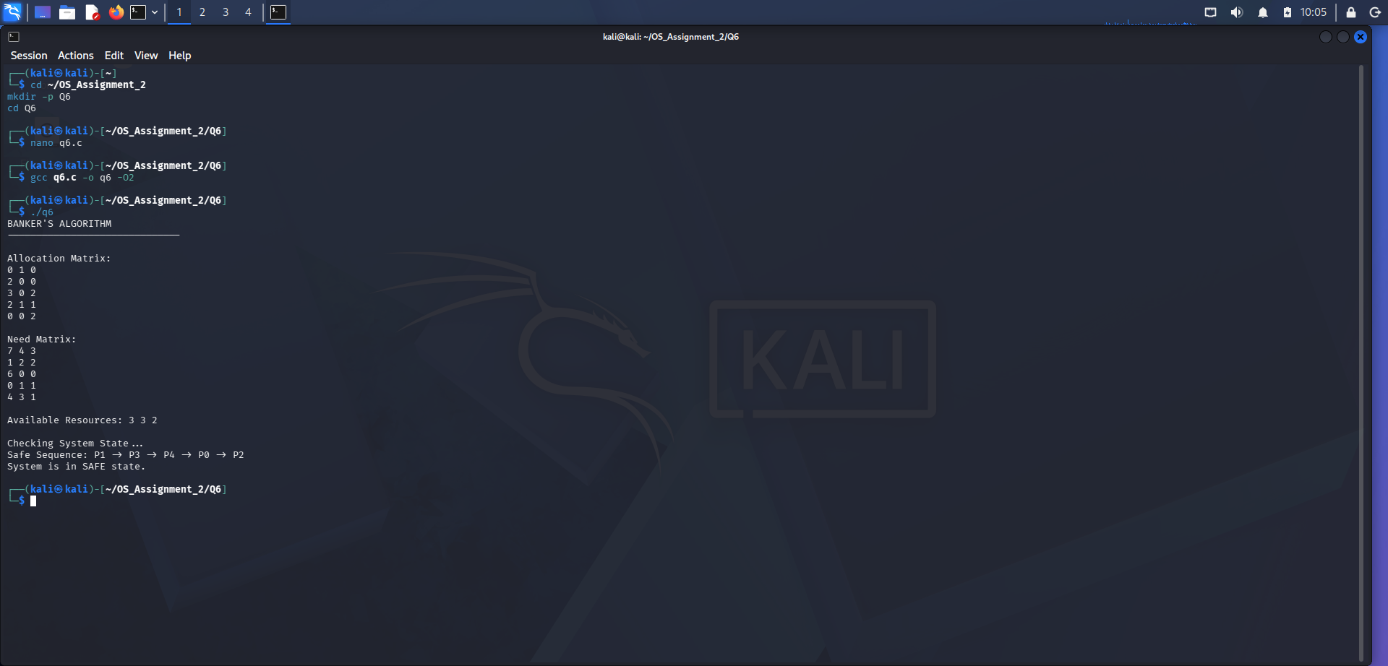

8. Unsafe Resource Request Analysis
Consider a request by process P0 for the resource vector:
Request = (2, 0, 2)
The original Available vector is:
Available = (3, 3, 2)
After temporarily allocating the requested resources:
New Available = (1, 3, 0)
The remaining Need of P0 becomes:
P0 Need = (5, 4, 1)
After this temporary allocation, none of the processes can satisfy its remaining resource requirement with the available resources.
Therefore, no safe sequence can be found.
Result: The request must be denied because granting it would place the system in an unsafe state.
An unsafe state does not necessarily mean that deadlock has already occurred. It means that the system cannot guarantee safe completion of all processes.

9. Deadlock Handling Strategies
A. Deadlock Prevention
Prevention avoids at least one of the four necessary deadlock conditions.
For example, resource ordering can prevent circular wait.
B. Deadlock Avoidance
Banker's Algorithm checks resource requests before granting them. A request is granted only if the resulting state remains safe.
C. Deadlock Detection
The operating system periodically checks resource allocation information to identify deadlocks.
D. Deadlock Recovery
After detecting deadlock, the operating system may terminate selected processes or recover resources to restore normal execution.

10. Alternative Concept and Complexity Analysis
Instead of running a deadlock detection algorithm periodically, the Banker's Algorithm can be used to check resource requests before allocation.
However, Banker's Algorithm requires the maximum resource demand of each process to be known in advance.
For n processes and m resource types, the safety algorithm has a worst-case complexity of approximately O(m × n²).
As the number of processes and resource types increases, the checking overhead also increases.
For a research centre, the Banker's Algorithm is suitable when resource demands are known and predictable.

11. Performance Measurement
The assignment requires measuring the execution time of the safety algorithm for 10, 100 and 1,000 processes.
The measurements should be collected by executing the program with different process counts.
The measured values should be recorded in the following table.
Number of Processes | Measured Time
10 | Insert actual result
100 | Insert actual result
1,000 | Insert actual result
The results can be compared with the theoretical complexity to understand how execution time changes as the workload increases.

12. Design Decision
For the research centre, Banker's Algorithm is a suitable deadlock-avoidance technique when maximum resource requirements are known.
It prevents unsafe allocations and helps maintain system stability.
However, for highly dynamic environments where maximum resource demands are not known in advance, deadlock detection and recovery may be more practical.

13. Conclusion
The experiment successfully demonstrated deadlock avoidance using Banker's Algorithm.
The program calculated the Need Matrix and identified the safe sequence P1 → P3 → P4 → P0 → P2.
The system was confirmed to be in a safe state. The additional request by P0 for (2, 0, 2) was found unsafe and should not be granted.
Therefore, Banker's Algorithm helps the operating system make safe resource-allocation decisions and avoid deadlock situations.

